**WeTuffy**

**Faceless App**

**Analysis Class Report**

**Revision History**

|  |  |  |  |  |
| --- | --- | --- | --- | --- |
| **Authors** | **Description of Change** | **Sections** | **Rev** | **Date** |
| Traci | Created document and shared it with the rest of the team | 1 |  | 2/25/19 |
| Arthur | Filled out project description | 2 |  | 3/11/19 |
| Arthur | Created the analysis class diagram | 2.1 |  | 3/11/19 |
| Traci | Worked on analysis class list | 2.2 |  | 3/11/19 |

**Table of Contents**

1 Team Description 4

2 Project Description 4

2.1 Analysis Class Diagram 6

2.2 Analysis Class List 7

2.2.1 Login 7

2.2.2 Receive Messages 7

2.2.3 Send Messages 8

2.2.4 Search Users 8

2.2.5 Customize Profile 9

# Team Description

|  |  |
| --- | --- |
| **Team Member Name** | **Email Address** |
| Brandon Luong | brandon.luong@csu.fullerton.edu |
| Arthur Salazar | art2015@csu.fullerton.edu |
| Yasmin Torres | torresyasmin21@csu.fullerton.edu |
| Traci Trojan | tracitrojan@csu.fullerton.edu |

# Project Description

Statement of Purpose: The purpose of Faceless is to give senders numerous means of messaging such as temporary messaging, and anonymous messaging, as well as your average messaging.

Detailed Description: The iOS app will consist of users that have multiple roles simultaneously:

* + Sender
  + Receiver

The Sender

The Sender can create messages that can be either:

* + - * Regular
      * Temporary
      * Anonymous

The Receiver

Depending on the message they get from the sender their messages would have unique features

* + - * Sender identity is known
      * Message is displayed for a short amount of time
      * Sender identity isn’t known

## Analysis Class Diagram

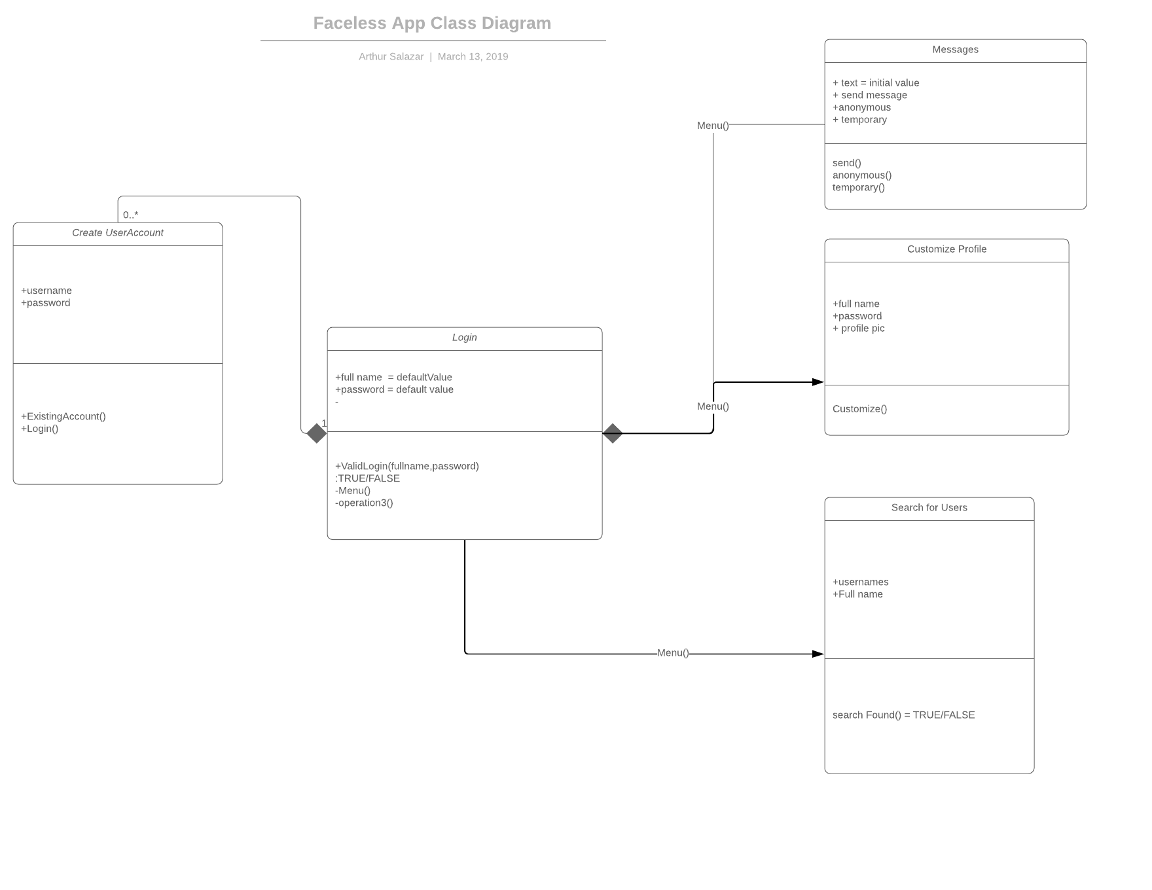

## Analysis Class List

|  |  |
| --- | --- |
| **Sequence Number** | **Analysis Class** |
| 1 | Login |
| 2 | Receive Messages |
| 3 | Send Messages |
| 4 | Search Users |
| 5 | Customize Profile |
| 6 |  |

### Login

Description:

Methods:

* GetFullName and password
* Validate fullname and password
* Permit Account access

Attributes:

* Full name
* Password
* Validation

### Receive Messages

Description:

Methods:

* Read regular message
* Read temporary message
* Read anonymous message

Attributes:

* Regular message
* Temporary message
* Anonymous message

### Send Messages

Description:

Methods:

* Send regular message
* Send temporary message
* Send anonymous message

Attributes:

* Create regular message
* Create temporary message
* Create temporary message

### Search Users

Description:

Methods:

* Search
* Validate fullname, username

Attributes:

* Username
* Full name

### Customize Profile

Description:

Methods:

* Change fullname, username
* Change password
* Change profile pic

Attributes:

* Fullname, username
* password
* Profile pic